# 第五周 数据库实验三

20123101 李昀哲

2022.12.29

## 实验内容

1. 检索选修课程包含1106同学所学全部课程的学生学号和姓名。
2. 查询每门课程中分数最高的学生学号和学生姓名。
3. 查询年龄小于本学院平均年龄，所有课程总评成绩都高于所选课程平均总评成绩的学生学号、姓名和平均总评成绩，按年龄排序。
4. 建立计算机学院总评不及格成绩学生的视图，包括学生学号、姓名、性别、手机、所选课程和成绩。
5. 在E表中插入记录，把每个学生没学过的课程都插入到E表中，使得每个学生都选修每门课。
6. 求年龄大于所有女同学年龄的男学生姓名和年龄。
7. 在选课表中修改08305001课程的平时成绩，若成绩小于等于75分时提高5%，若成绩大于75分时提高4%。
8. 删除没有开课的学院。
9. 查询优、良、中、及格、不及格学生人数。

## 实验过程

1. **检索选修课程包含1106同学所学全部课程的学生学号和姓名。**

找出1106所学全部课程的course_id;

找到选修课程包含上述course_id的学生学号；

根据学生学号找姓名；

Sql代码：

|  |
| --- |
| SELECT `name`,student_id  FROM  student  WHERE  student_id IN (  SELECT DISTINCT student_id  FROM  `course selection`  WHERE EXISTS (  SELECT  course_id  FROM  `course selection`  WHERE  student_id = '1106'  )  ) |

结果：

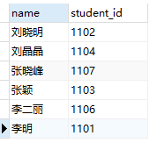

1. **查询每门课程中分数最高的学生学号和学生姓名。**

|  |
| --- |
| select DISTINCT course_id, student.student_id, student.name  from student, `course selection`  where  student.student_id = `course selection`.student_id and  `course selection`.total_score in  (select max(total_score)  from `course selection`  GROUP BY course_id) |

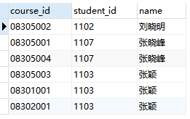

1. 查询年龄小于本学院平均年龄，所有课程总评成绩都高于所选课程平均总评成绩的学生学号、姓名和平均总评成绩，按年龄排序。

先给出基本框架：

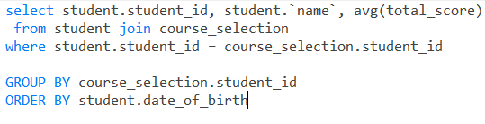

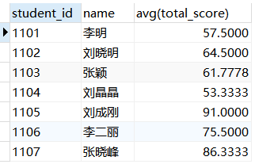

无非就是在上面这些人里选：

|  |
| --- |
| select student.student_id, student.name  from student, `course selection`  where 2022-YEAR(date_of_birth) < (select avg(2022-YEAR(date_of_birth)) from student) and  `course selection`.student_id = student_id and min(total_score)> |

1. 建立计算机学院总评不及格成绩学生的视图，包括学生学号、姓名、性别、手机、所选课程和成绩。

|  |
| --- |
| create view student_fail(student_id, name, sex, mobile_phone, course_id, grade) as (SELECT student.student_id, student.name, sex, mobile_phone, course_id, total_score from student, `course selection` where student.student_id = `course selection`.student_id and total_score < 60) |

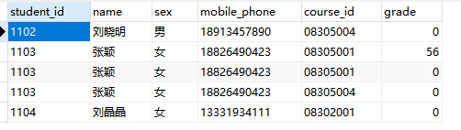

1. 在E表中插入记录，把每个学生没学过的课程都插入到E表中，使得每个学生都选修每门课
2. 求年龄大于所有女同学年龄的男学生姓名和年龄。

|  |
| --- |
| select student.name, 2022-year(date_of_birth) 年龄  from student  where sex = '男' and  2022-year(date_of_birth) > (select min(2022-year(date_of_birth)) from student where sex='女') |

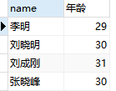

1. 在选课表中修改08305001课程的平时成绩，若成绩小于等于75分时提高5%，若成绩大于75分时提高4%。

注意，两句需要分开执行

|  |
| --- |
| update `course selection` set `normal_ score` = `normal_ score` * 1.04 where `normal_ score` > 75 and course_id='08305001'  update `course selection` set `normal_ score` = `normal_ score` * 1.05 where `normal_ score` <= 75 and course_id='08305001' |

1. 删除没有开课的学院。

|  |
| --- |
| delete from department where dept_id not in (select dept_id from course where course_id not in (select course_id from `course selection`)) |

1. 查询优、良、中、及格、不及格学生人数。

|  |
| --- |
| 优：  select student_id from `course selection` group by student_id having avg(total_score) > 90  良：  select student_id from `course selection` group by student_id having avg(total_score) > 80  中  select student_id from `course selection` group by student_id having avg(total_score) > 70  合格  select student_id from `course selection` group by student_id having avg(total_score) > 60  不合格  select student_id from `course selection` group by student_id having avg(total_score) < 60 |

